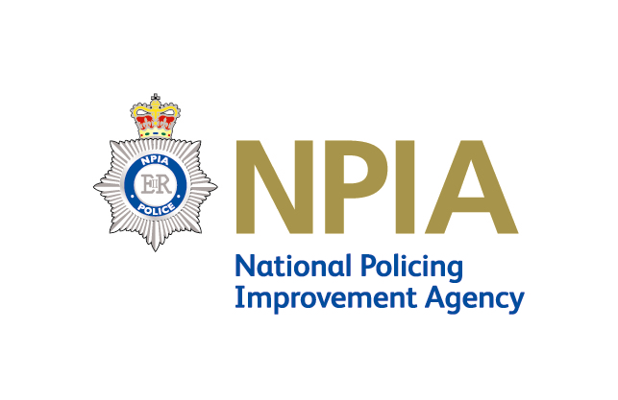
National Policing Improvement Agency (NPIA)

ISIS Communications Working Group

17 March 2009

Contacts

Name and title | Organi-sation | Phone number | Email
Kay Odysseos/ maternity cover  Marketing and Communications manager | NPIA | 020 8358 5554/  020 7147 8027 | Kay.odysseos@npia.pnn.police.uk
Emma Jones  Marketing and Communication officer – ISIS | NPIA | TBC – starts end April | TBC
Nick Kelly  Senior Policy adviser – ISIS | NPIA | 07799094813 | Nick.kelly@npia.pnn.police.uk
Nasra Jama  Policy assistant – ISIS | NPIA | 020 7147 8488 | Nasra.jama.npia.pnn.police.uk
Amanda Palmer  Press officer | ACPO | 020 7084 8946 | press.office@acpo.pnn.police.uk
Alex Moate | MPS | 020 | Alexandra.Moate@met.police.uk
Chris Cairns  Communications Manager | APA | 020 7664 3174 | chris.cairns@lga.gov.uk
David Close  Programme Communications Manager | OCJR | 020 7035 8111 | David.Close@cjit.gsi.gov.uk
Suzy Burton  Head of Policing Communications | HO | 020 7035 1248 | Suzy.Burton@homeoffice.gsi.gov.uk

